Promotional Material for the Christos Project
(Video and Printed Advertisements)

www.adamwyborn1.com

The Christos Project

Discover 42 inspiring books exploring Christianity, philosophy, and the eternal truth of Jesus Christ. The Christos Project offers spiritual wisdom, historical insight, and deeper understanding for readers seeking meaning, faith, and truth in today’s world.

Begin your journey through the history of redemption today.

Watch Our 1-Minute Promotional Video

https://drive.google.com/file/d/1rPvAY3aoxXeADnxvrA06wcU9rHMbeMaN/view?usp=drive_link

Watch Our 5-Minute Promotional Video
https://drive.google.com/file/d/1OVzWzux9F8NqTn0DESce-yN8msyK6l-0/view?usp=drive_link

Item 1) Full Printed Library Promotion 1

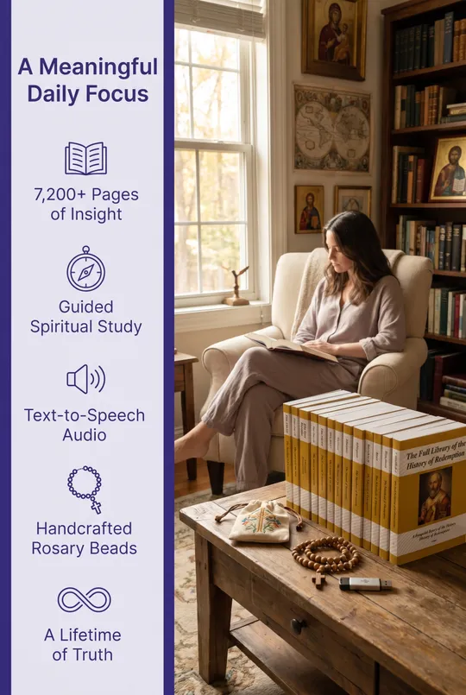

Item 2) Rosary and Notes Promotion

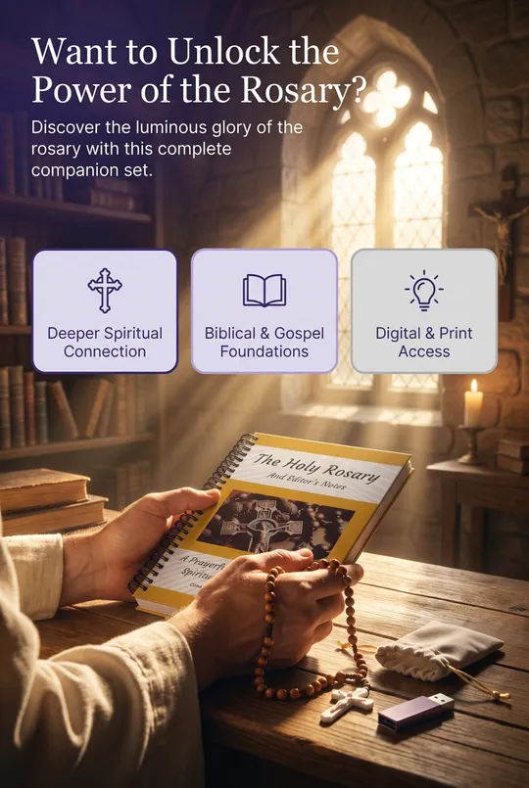

Item 3) Guidebook to the History of Redemption Promotion



Item 4) Rosary Beads, Flash Drive, and Pouch Promotion

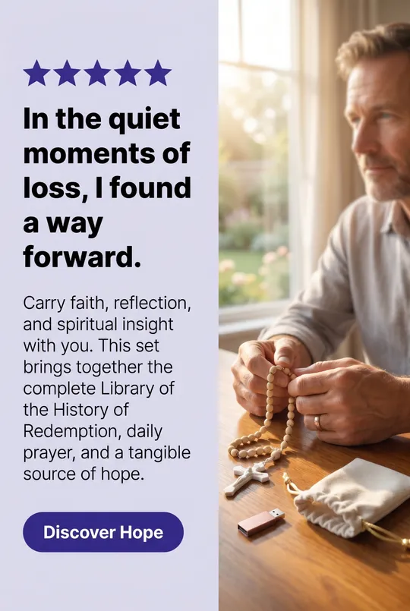

Items 7,8,9) Musical Poetry Promotion



